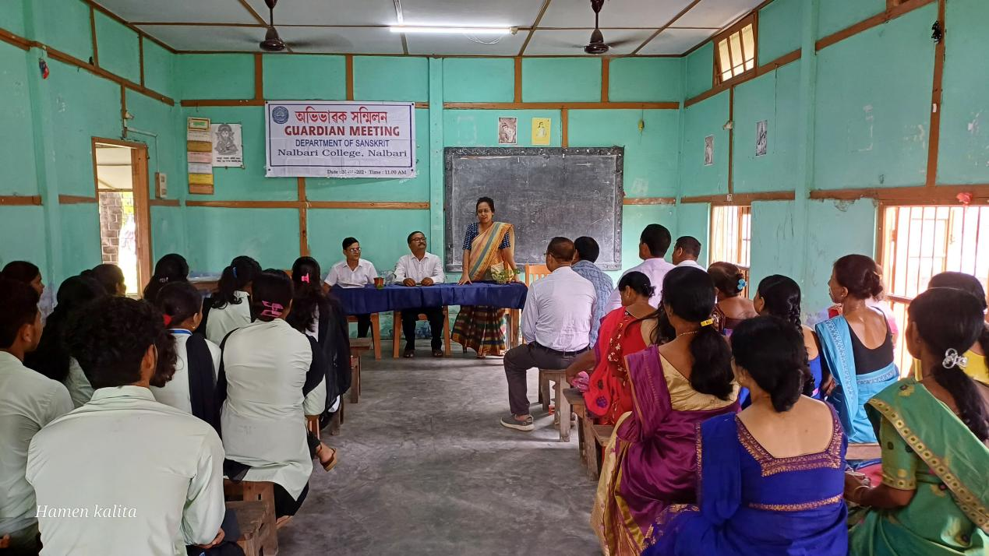

- Title of the event: GUARDIAN MEET
- Venue: Department of Sanskrit, Nalbari College
- Date: 31-08-2024
- Organized by: Guardians, Teachers and Students, Dept. of Sanskrit, Nalbari College

- Faculty Coordinator: Dr. Rupsmita Buarbaruah

- No. of Participants in details (students): 52

- Nature of Participation: Guardians, Teachers and Students

- Activities Carried out / Detail Description of the event:

A Guardian Meeting has been arranged at the Department of Sanskrit, Nalbari College on 13.08.2024 at the West Block of Nalbari College under the presidenship of Dr. Goutam Choudhury. Prof. Phatik Chandra Barman has inaugurated the programme with his valuable speech expressing golden heritage of Sanskrit Department and Nalbari College. Some of the Guardians have expressed their observation in respect of Study, Textbook purchasing, Use of Mobile, Use of Two-wheeler without wearing helmet etc. by the student. Dr. Rupsmita Buzarbaruah of the Sanskrit has also shared her experience with the mother present in the meeting regarding upbringing of their wards in this adolescence period, which is significant in the lifeline of every student. The meeting ends with a vote of thanks from the chair.

