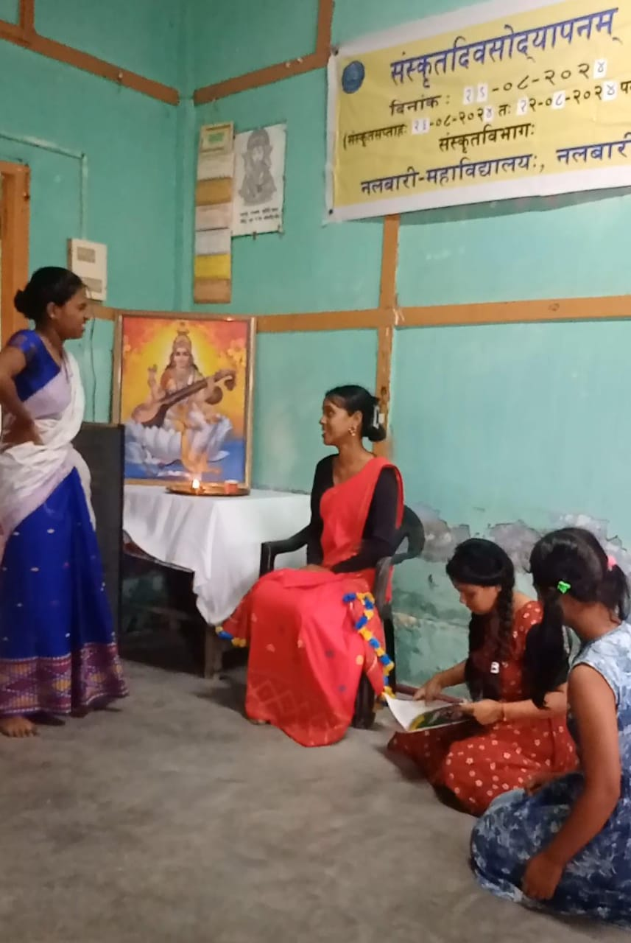

- Title of the event: SANSKRIT DIVAS
- Venue: Department of Sanskrit, Nalbari College
- Date: 19-08-2024
- Organized by: Teachers and Students, Dept. of Sanskrit, Nalbari College

- Faculty Coordinator: Dr. Goutam Choudhury

- No. of Participants in details (students): 63

- Nature of Participation: Students &Teachers

- Activities Carried out / Detail Description of the event:

On the auspicious occasion of Shravanai Purnima, the world Sanskrit Divas is observed. The famous Raksha Bandhana festival is also maintained on that day. The first World Sanskrit Day was celebrated in 1969 by the Govt. of India. The organisation like Sanskrit Bharati, Lokabhasha Prasar Samiti, etc. have advised to organise the same w.e.f. 16-08-2024 to 22-08-2024 as Sanskrit Week. As the mother of almost all Indian languages, the Sanskrit is one of the oldest languages in the world. The day is celebrated across the country to exhibit the heritage of Sanskrit language and to popularise the same among common people.

The Department of Sanskrit, Nalbari College celebrated Sanskrit Divas on 19th of August, 2024. Most of the students of Sanskrit are participated in this program. Also some students are participated in the event of Sanskrit Drama, Sanskrit Song, Sanskrit Speech conducted in connection with this event. At the end four students are performed dance in classical songs. In this program, Sjt. Jagannath Sharma, a renown Sanskrit author delivered a valuable speech as Chief Guest.

