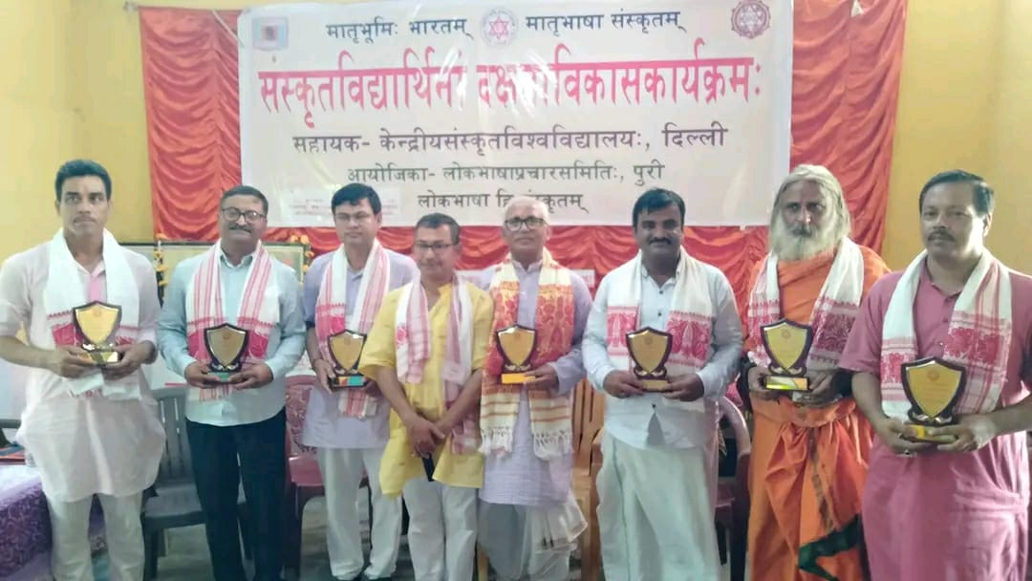

- Title of the event: 10 Days Residential Skill Development Programme for Sanskrit Students
- Venue: Sanskradev Sisu Niketan, Kaithalkuchi
- Date: 15-07-2024 to 24-07-2024 (10 Days)
- Organized by: Lokabhasha Prashar Samittee in association with several organisations including Dept. of Sanskrit, Nalbari College

- Faculty Coordinator: Dr. Goutam Choudhury

- No. of Participants in details (students): 112 participants from different institutions (7 from Sanskrit Department, Nalbari College)

- Nature of Participation: Students &Teacher

- Activities Carried out / Detail Description of the event:

A 10 Days Residential Skill Development Programme for Sanskrit Students is organised at Sankradev Sisu Niketan, Kaithalkuchi under the aegis of Lokabhasha Prashar Samittee. Several organisations are there as collaborating agencies. The Department of Sanskrit, Nalbari college has also participated. Sanskrit Scholars of International repute have joined as teaching faculties for Skill development of the participants. Students are found to have developed their Speaking Skill in Sanskrit Language. They have presented Sanskrit Song, Dance in traditional attire, Sanskrit Drama, Sanskrit Poem recitation etc. including Yoga and other classes of Sanskrit Learning therein. A rally for day to day use of Sanskrit language has been organised. On the concluding day of that 10 Day Residential Camp, Varnali Deka, IAS, District Commissioner, Nalbari graced the occasion.

