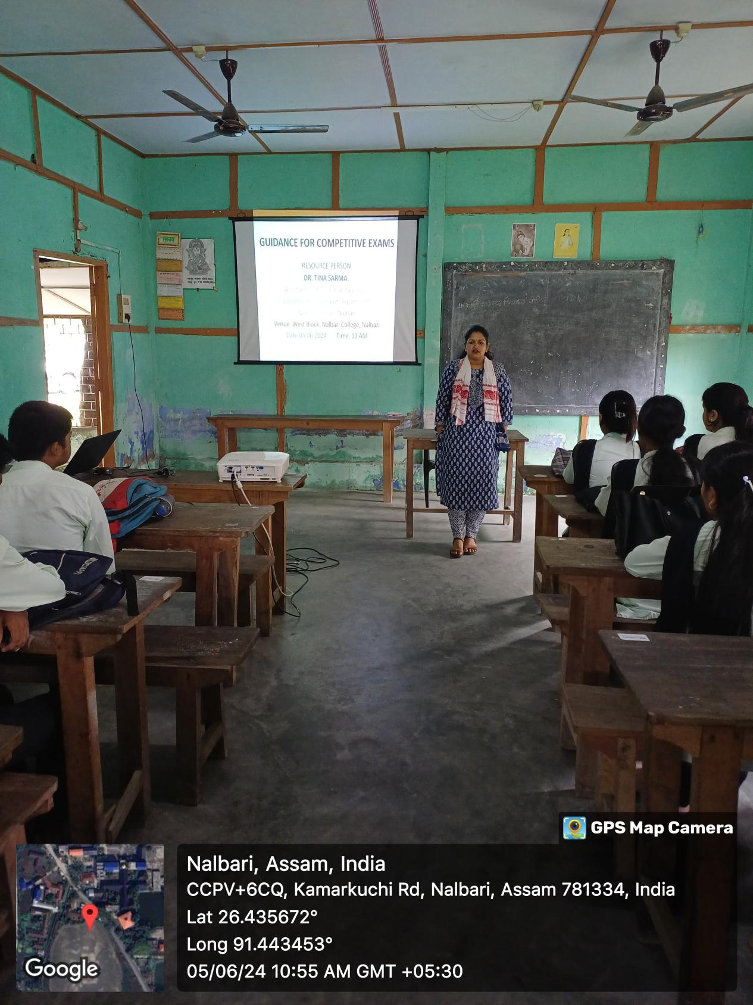

- Title of the event: GUIDANCE FOR COMPETITIVE EXAMINATIONS

- Venue: Department of Sanskrit, Nalbari College

- Date: 05-06-2024

- Organized by: Teachers and Students, Dept. of Sanskrit, Nalbari College

- Faculty Coordinator: Mr. Hamen Kalita

- No of Participants in details (students): 30

- Nature of Participation: Students &Teachers

- Activities Carried out / Detail Description of the event:

A programme on Guidance for Competitive Examinations has been organised by the Department of Sanskrit, Nalbari College on 05.06.2024 at West Block of Nalbari College. Dr. Tina Sharma, Asstt. Professor of Rangia College has guided the students of Sanskrit Department for Competitive Examinations like NET, SLET (SET), TET, Banking sectors etc. Students are highly benefited by the guidance of the Resource Person.

