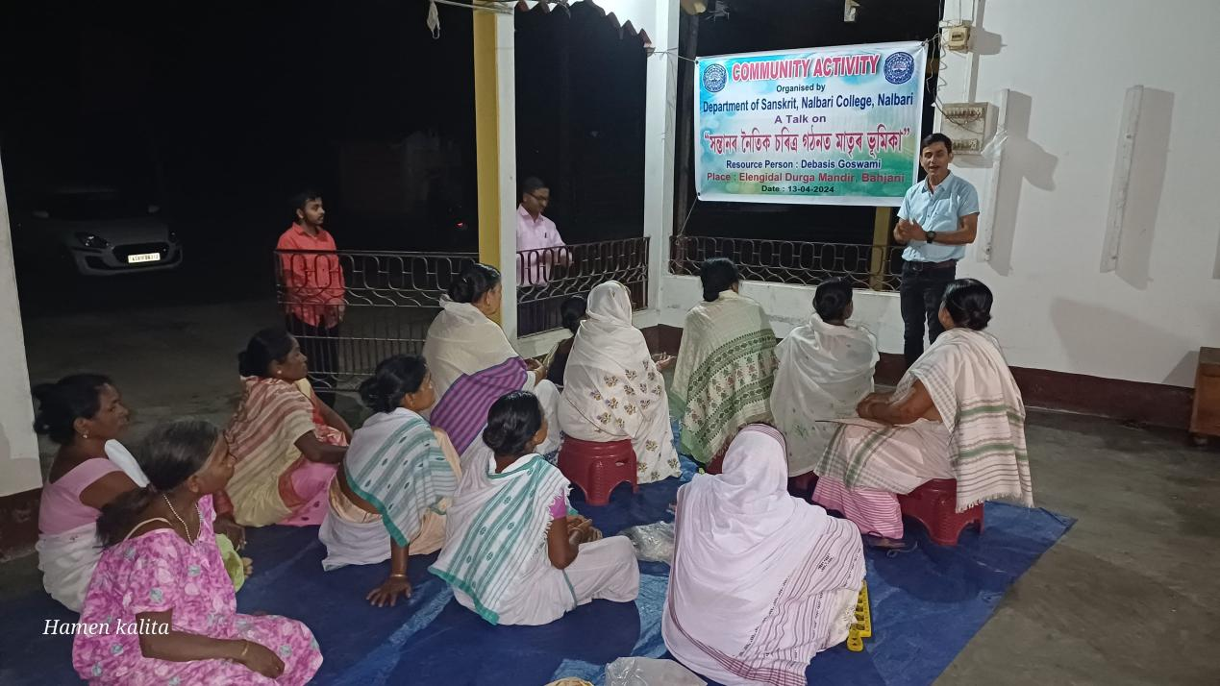
- Title of the event: COMMUNITY ACTIVITY
- Venue: Durga Mandir, Vill. Elengidal (Choudhurypara), Bahjani, Nalbari
- Date: 13-04-2024
- Organized by: Dept. of Sanskrit, Nalbari College

- Faculty Coordinator: Mr. Debasis Goswami

- No. of Participants in details (students): 28

- Nature of Participation: Teachers, Dept. of Sanskrit, Nalbari College and Women from Vill. Elengidal, Bahjani, Nalbari

- Activities Carried out / Detail Description of the event:

A Community activity has been organised by the Department of Sanskrit, Nalbari College on 13.04.2024 at the Durga Mandir of Village - Elengidal (Choudhurypara), Bahjani, Nalbari. Mr. Debasis Goswami, teacher of Sanskrit Department has delivered a lecture on a topic “নৈতিক চৰিত্ৰ গঠনত মাতৃৰ ভূমিকা” among the learning audience of that local community. The women of that village actively participated in the programme. They have come to know about the role of mothers in upbringing of the wards.

