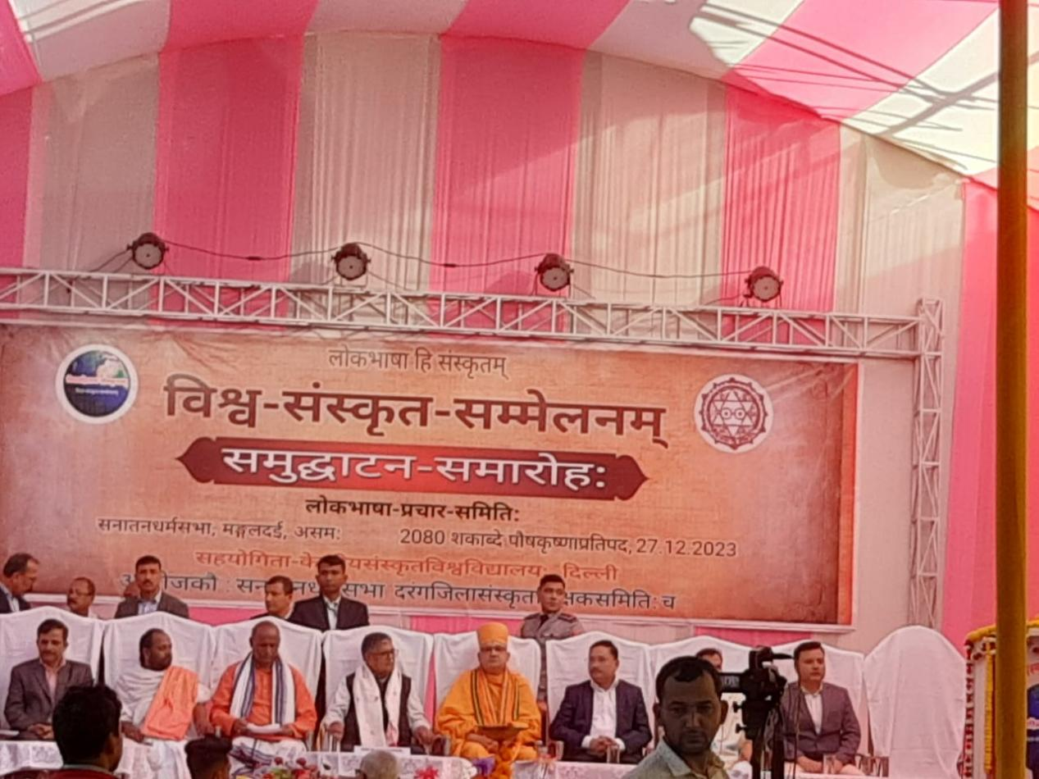
- Title of the event: FIELD TRIP FOR WORLD SANSKRIT CONFERENCE
- Venue: Mangaldoi, Assam, India
- Date: 27-12-2023 to 29-12-2023
- Organized by: Teachers and Students, Dept. of Sanskrit, Nalbari College
- Faculty Coordinator: Dr. Goutam Choudhury
- No of Participants in details (students): 25
- Nature of Participation: Students &Teachers
- Activities Carried out / Detail Description of the event:
The students of the Department of Sanskrit, Nalbari College have taken active part in WORLD SANSKRIT CONFERENCE at Mangaldoi, Assam, India w.e.f. 27-12-2023 to 29-12-2023. It has been organised by Lakabhasha Prashar Samitee, India. Students of Nalbari College are highly benefited by the different events of the conference.
