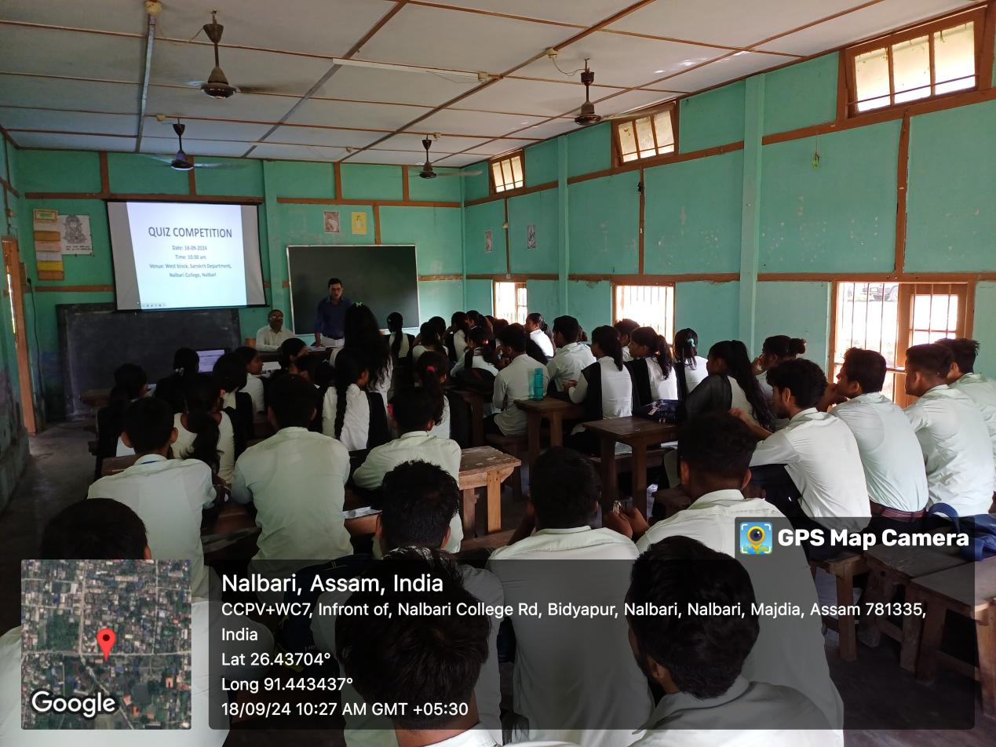
- Title of the event: Sanskrit Quiz Competition
- Venue: West Block, Nalbari College
- Date: 18-09-2024
- Organized by: Teachers and Students, Dept. of Sanskrit, Nalbari College
- Faculty Coordinator: Debasis Goswami
- No of Participants in details (students): 43
- Nature of Participation: Students &Teachers
- Activities Carried out / Detail Description of the event:
A Sanskrit Quiz Competition has been organised by the Department of Sanskrit, Nalbari College on 18-09-2024. Mr. Debasis Goswami coordinated the program in presence of the teachers and students. Question from general knowledge as well as of Sanskrit literature are asked to the participants. All are highly benefited.
