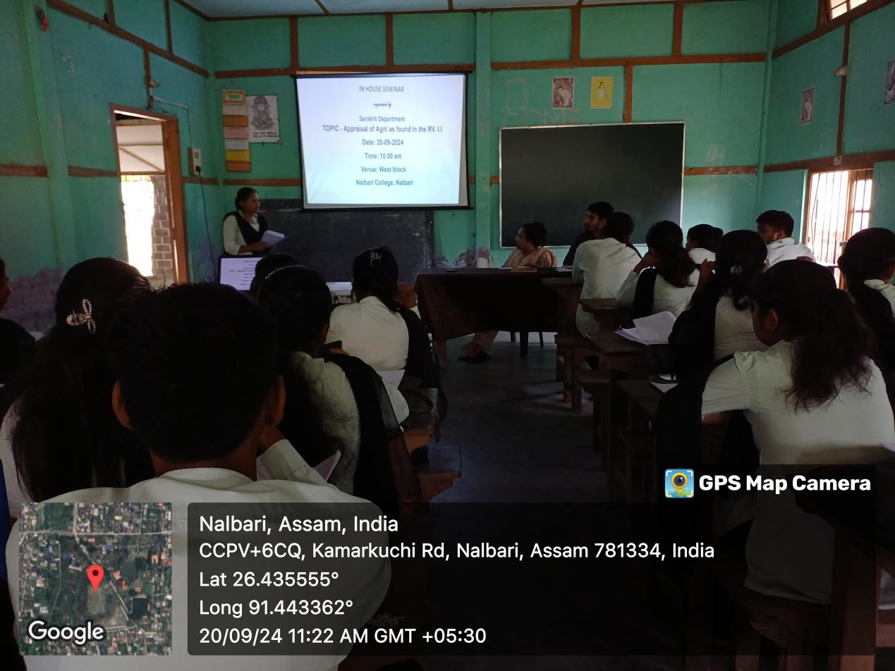
- Title of the event: In House Seminar
- Venue: West Block, Nalbari College
- Date: 20-09-2024
- Organized by: Teachers and Students, Dept. of Sanskrit, Nalbari College
- Faculty Coordinator: Dr. Rupsmita Buzarbaruah
- No of Participants in details (students): 28
- Nature of Participation: Students &Teachers
- Activities Carried out / Detail Description of the event:
A In House Seminar has been organised by the Department of Sanskrit, Nalbari College for the students of 5th Semester (Honors)-CBCS on 20-09-2024. The students presented their write up on “APPRAISAL OF AGNI AS FOUND IN THE RV-I.1”. Dr. Rupsmita Buzarbaruah commented on each paper as chairperson. Mr. Hamen Kakati, a Faculty member also interacted with the students with some vibrant observations.
