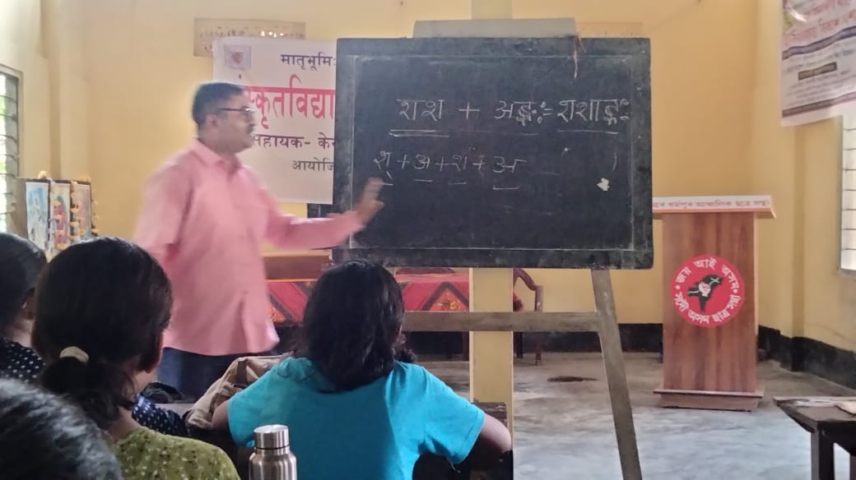
- Title of the event: Outreach Program
- Venue: West Block, Nalbari College
- Date: 21-07-2024
- Organized by: Dept. of Sanskrit, Nalbari College
- Faculty Coordinator: Dr. Goutam Choudhury
- No of Participants in details (students): 56
- Nature of Participation: Students of School
- Activities Carried out / Detail Description of the event:
An Outreach Program is organised at Sankardev Sishu Niketan, Misrapara, Nalbari among the students of that school on 21-07-2024. Dr. Goutam Choudhury communicated with the participants in demonstration. All the students are found inspired.




