- Name of the Department/Center/Cell/Committee: Zoology

- Title of the event: Extension Activity of the Department

- Venue: Kamrup Vidyapith High School, Bala Mugkuchi

3. Date: 29-05-2026

- Organized by: Department of Zoology in association with Department of Chemistry and IQAC, Nalbari College.

- Programme Coordinator(s): Dr. Nabajyoti Deka and Prof. Kumud Ch. Rabha

- Name of the Resource Person: Dr. Nabajyoti Deka and Prof. Kumud Ch. Rabha

No. of Participants: 50

- Nature of Participation: Students of Class-IX and Class-X

- Activities Carried out/Description of the event: (A Short Paragraph should be written about the event): A talk was deliverd by Prof. Kumud Chandra Rabha on Biodiversity its importance in ecosystem. The talk highlights on the conservation of species and maintaining the ecological balance.

- Event Photographs:

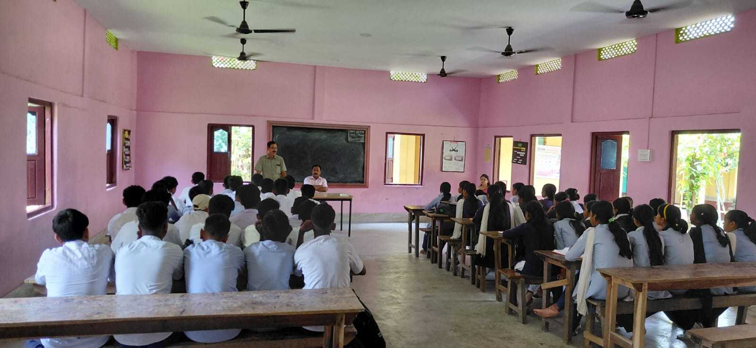

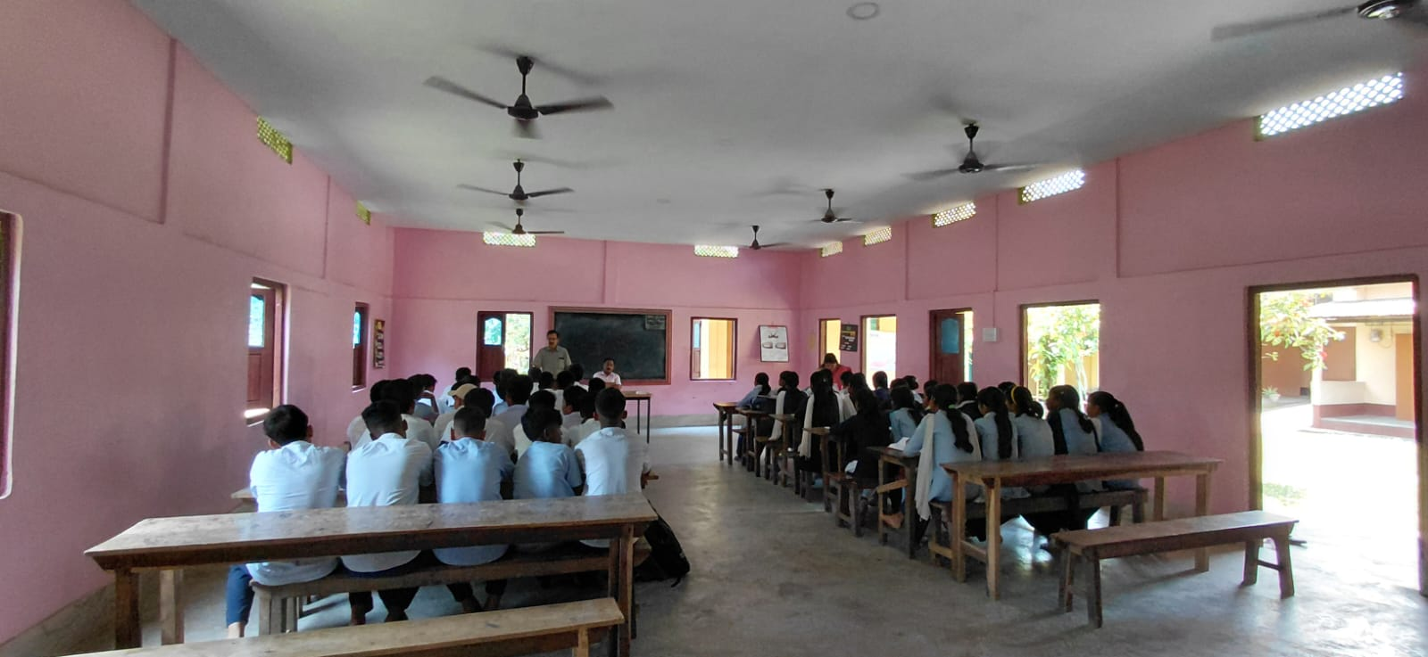

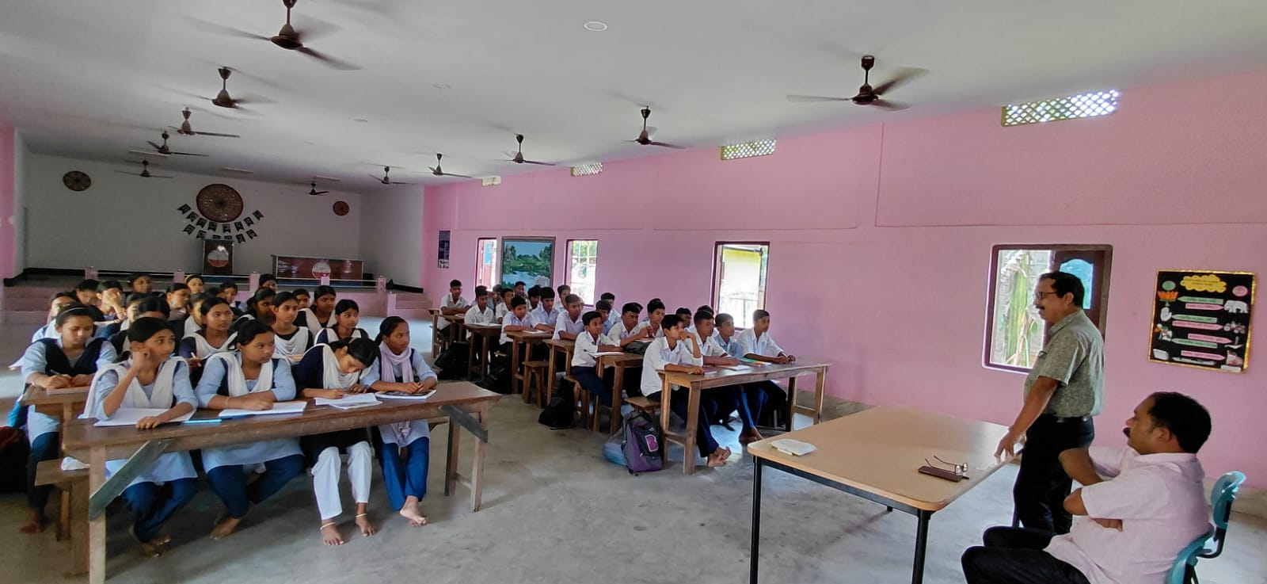

- Signature of Participants:

