NOTICE
30-11-2024

This is to inform all the students of 3rd Semester (Hon.), Dept. of Sanskrit, N.C., that the VIVA-VOCE Examination against Paper Name – Sanskrit and Indian Knowledge System, Paper Code – SKT-SEC-036703 is scheduled to be held on 05-12-2024 (Thursday) at 11 am onwards. The Examinees are advised to appear on time.

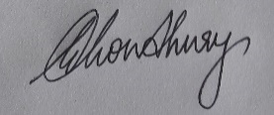
(DR. GOUTAM CHOUDHURY)
HoD., Sanskrit, Nalbari College

