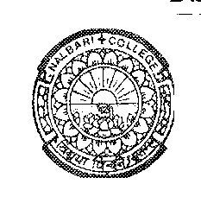

DEPARTMENT OF POLITICAL SCIENCE
NALBARI COLLEGE, NALBARI, (ASSAM)

Estd: 1945

Ref: Pol. SEC Practical 1st Sem-2024 Date:05/12/2024

NOTICE

It is an information to all B.A 1st Semester (NEP) students having SEC in Political Science of Nalbari College, that the Viva (Practical) exam would be conducted on following date and time.

Paper: Panchayati Raj in Practice
Paper Code: SEC0107203
Date: 10-12-2024 (Tuesday)
Time: 10 AM –12.00 Noon
Room: AB-11
Sd/
HOD, Pol. Science
Nalbari College, Nalbari

