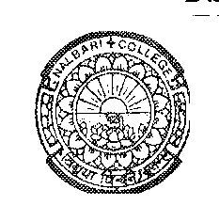

DEPARTMENT OF POLITICAL SCIENCE
NALBARI COLLEGE, NALBARI, (ASSAM)

Estd: 1945

Ref: Pol. SEC Practical 3rd Sem-2024 Date: 05/12/2024

NOTICE

It is an information to all B.A 3rd Semester (NEP) students having SEC in Political Science of Nalbari College, that the Viva (Practical) exam would be conducted on following date and time.

Paper: Parliamentary Procedures and Practices
Paper Code: SEC0302703
Date: 10-12-2024 (Tuesday)
Time: 10 AM –12.00 Noon
Room: AB 23
Sd/
HOD, Pol. Science
Nalbari College, Nalbari

