DEPARTMENT OF POLITICAL SCIENCE
NALBARI COLLEGE, NALBARI, (ASSAM)
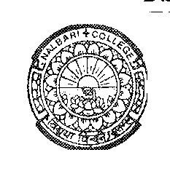
Estd: 1945
Ref: Assignment-Submission-Dateline Date: 3/4/2025

Assignment Submission Notice

The datelines for submission of Home Assignment and Project of Political Science for all Even Semesters, 2025 are mentioned below:

Semester | Paper | Date | Time
BA 6th (CBCS)  Honours and RE/RG | HC & HE  RE/RG/SEC | 21/4/2025 | 9.00 AM--1.00 PM
BA 2nd (FYUGP)  ALL | Major/Minor and SEC | 22/4/2025 | 9.00 AM--1.00 PM
BA 4th (FYUGP)  Major and Minor | Major & Minor | 24/4/2025 | 9.00 AM--1.00 PM

Sd/
HOD, Pol. Science
Nalbari College, Nalbari

