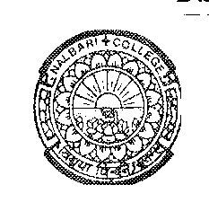

DEPARTMENT OF POLITICAL SCIENCE
NALBARI COLLEGE, NALBARI, (ASSAM)

Estd: 1945

Ref: Pol. SEC Practical 2nd and 6th Sem-2025 Date: 3/6/2025

NOTICE FOR SEC VIVA

It is an information to all FYUGP 2nd Semester and B.A 6th Semester students having SEC in Political Science of Nalbari College, that the Viva (Practical) exam would be conducted on following date and time.

Date | Semester | Time | Room | Paper
6/6/2025 | BA 6th | 9.00--10.00 AM | AB-23 | Conflict and Peace Building
6/6/2025 | FYUGP 2nd | 10.00--12.00 AM | AB-23 | Conflict and Peace Building

Sd/
HOD, Pol. Science
Nalbari College, Nalbari

NB: Students are asked to bring Admit Card for Viva.

